**Nota**: Matlab Central para foros.

**Plotting matrices as images**

In the plot tab, you can find several functions to do so:

**imshow (matrix)** = It plots an image from a matrix in a Handle Graphics figure. This image can be in grayscale (each element of the matrix is a number between 0 and 255), RGB (each element of the matrix is a three-element vector with numbers between 0 and 255) or binary (each element is 0 or 1).

**imtool (matrix)** = Like imshow but allows you to play more with the image and pre-process it. You can also use the tool inspect pixel value in order to see at the same time the image and the value of the matrix element.

**Importing images**

In order to import an image, you can start by double-clicking it in the current folder. Then the import wizard window opens, which adapts to your data type:

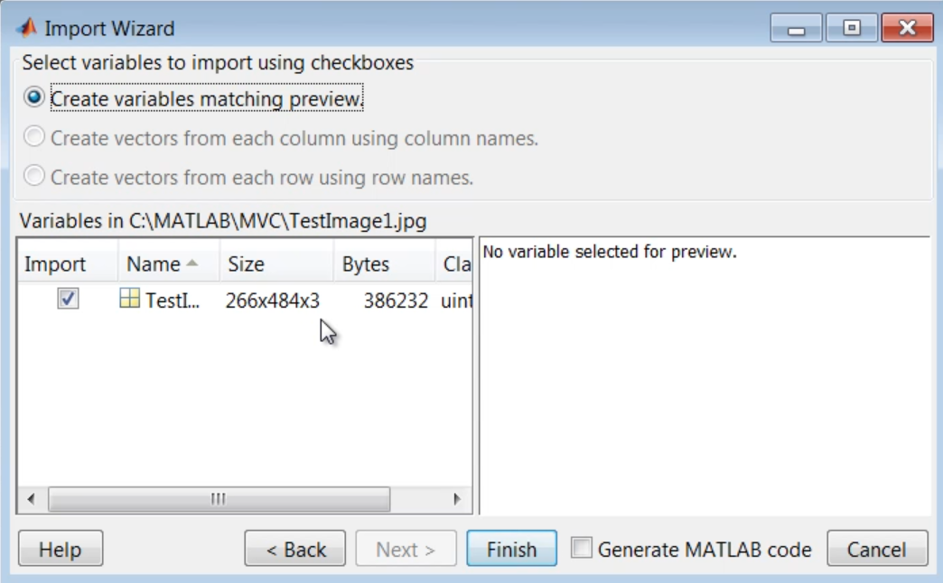

You can also use the function **imread (‘filename’,format)** to import images into MATLAB.

**Image segmentation:** It allows us to isolate elements of an image from the background. In order to do that, we can erase the background by subtracting one matrix image to the other and keeping the absolute value.

**bwareaopen(‘binary image’,’pixel size’)** = It removes from a binary image all objects that have a dimension fewer than the specified pixel size.

**regionprops(‘binary/cc/labeled matrix’, ‘properties’) =** Measures a set of properties of the objects in a matrix.

The button **“Publish”** in the Editor window allows you to create a .html document to better present your algorithm.

**Working with video**

You can use an USB camera by accessing to the Add-Ons window and selecting it into the hardware options list.

**User interface**

We can create a user interface by using the GUI. We can call the GUI editor window by calling the guide function at the workspace.